Best Legally Purchasable 3DS to PC port of Minesweeper 2026
Kane Butler
Description | Screens
Title / Welcome  Menu options | Welcome to  (Minesweeper)((Ascii text))  Thank you for willingly participating  Options:  - Play game  - Access scoreboard  - Exit  Choose an option:
Score board | 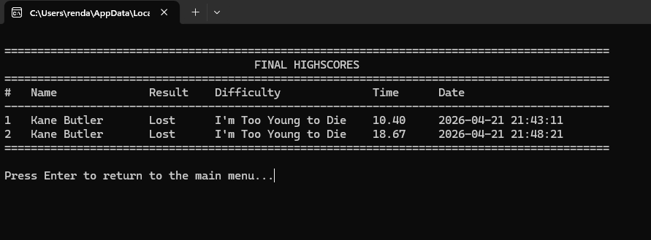
Minesweeper game | 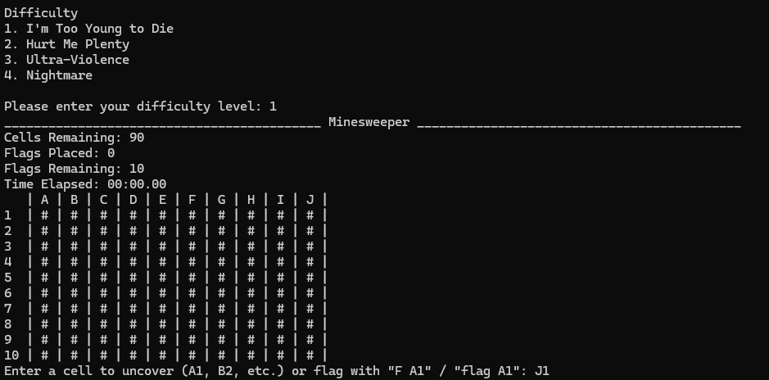
Game Over Screen | 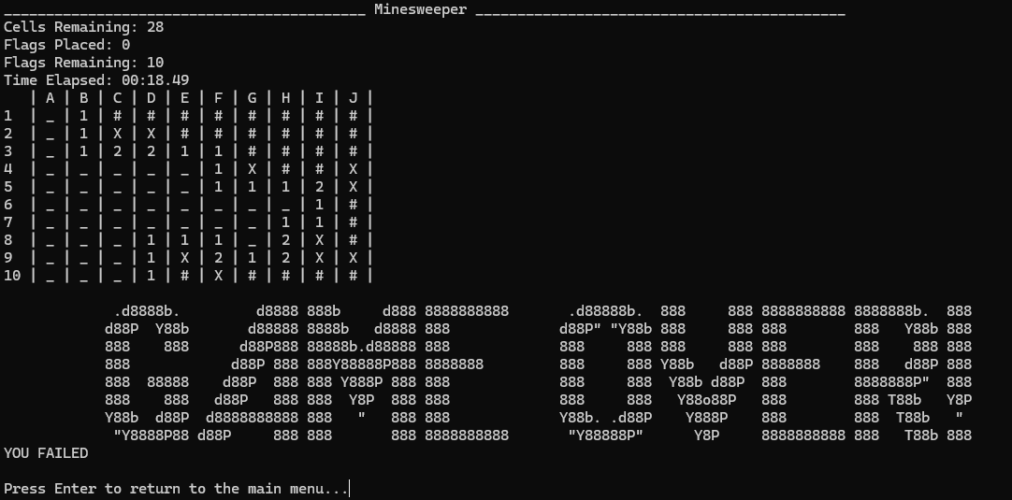
Winning Screen | 